Symbiota: preparing images
Text by Mary E. Barkworth; original image of Cadia purpurea by Helen Pickering. Prepared 2017-07-06.

Images in Symbiota Networks
Symbiota’s ability to show multiple images of organisms, particularly living organisms, is one of the reasons that Symbiota-based web sites are popular. These instructions provide guidance on how to provide high quality images to a Symbiota network.
Symbiota networks has two tools for accepting images. One, the “Basic Field Image Submission module”, is for images that are being provided just to show what a particular taxon looks like; the other, the “Image Observation Submission Module”, is for images that are being submitted to document the occurrence of the taxon at a particular location at a particular time. The primary difference between the two is that submitting a “Basic Field Image” requires only that the name of the taxon be provide although the form allows addition of location and habitat information – but not latitude and longitude. An “Image Observation”, or more completely, and image-based occurrence record, requires that you provide the latitude and longitude of the place where the image was recorded in addition to the name. The associated form also encourages completion of all the fields used to document a specimen-based occurrence record. Image-based occurrence records are particularly useful if the species involved is rare or you do not have a permit to collect a specimen. It is easy to submit multiple images for image-based observations. Take advantage of this to submit images that, in combination, show all the features considered important to identification.

Permission to submit images
Links to both image upload modules will be seen on the site map if you have permission to upload images. If you do not see these links, you need to request permission to submit images. Only network managers can give such permission because it is important that the images be correctly identified and of high quality. If you wish to have permission to add images, contact the network manager. If you are not known to the network manager, when asking permission, please provide the name of someone who can support your request (for example, publications that include photographs you have taken or the name of a manager of one of the collections that contribute to the network). The network manager for OpenHerbarium and OpenZooMuseum is Mary Barkworth (mary.barkworth [at] usu.edu).

Permissions for image use
Symbiota allows image providers to place copyright restrictions on their images but some networks may limit the choices so as to increase the value of the network to general users. For example, OpenHerbarium and OpenZooMuseum will only allow images to be posted if they are licensed under the Creative Commons license CC BY (https://creativecommons.org/licenses/) or are placed in the public domain. CC BY requires users to credit the original photographer but allows image modification and use in commercial publications. Images that are in the Public Domain can be used without restriction but users are strongly encouraged to give credit to the original photographer.
As the instructions below make clear, the images provided by the web site should have a relatively small file size so that they will download rapidly. Users wanting a high-quality file can contact the provider and request that they be sent the original file but the provider may charge for its use and/or place additional restrictions on its use.

Preparing the images
Images should be of high quality. This means they must be in focus and feature something about the plant (flower, growth form, habitat) that will aid those seeking to identify the species. They must also be smaller than 2MB. Smaller is better because small files download faster than large files.
The file size of an image is the digital size of the image file, measured in kilobytes (KB), megabytes (MB), or gigabytes (GB). It reflects to the pixel dimensions of the image but also the amount of memory used to store information about color depth, hue, layers, and channels. File format also affects file size because of the varying compression methods used. All this means is that file sizes can vary considerably for the same pixel dimensions. To check file size, you need to look at the file listing in its folder, not the file size reported in Photoshop under “File size”.
Images being used for print publication need to be larger than those intended for monitor display because the differences in detail show up more in print. They would also allow one to zoom in more on a monitor but the problem is that the download time would be considerable, even impossible for some users. That is why one should minimize the size of images submitted to Symbiota networks. Small images also save server space but it is the download time for users that is the critical concern.

Instructions
The following steps are those I take in preparing images for upload. It does not matter in what order you do the last two steps. I use Photoshop. Other programs have similar abilities.
Always save your modified files under a different name from the original file.
- Open the file (Fig. 1). Size: 5.023 MB
- Crop the file so that the feature of interest is highlighted. It is also good to make images more or less square – they look better when many images are viewed at once. Size 2.74 MB
- Save as JPG file with a quality of 8-10. Size: 581 KB. This is OK but the next step will make the image download faster.
- Reduce maximum dimension to 1000 pixels. This will be too big for some monitors but not all. It is an easy number to remember. Size: 218 KB
Figures 1-4 illustrate the impact of each of the above but, inevitably, does so in print format.
Figure 1. Original file. Size 5.023MB
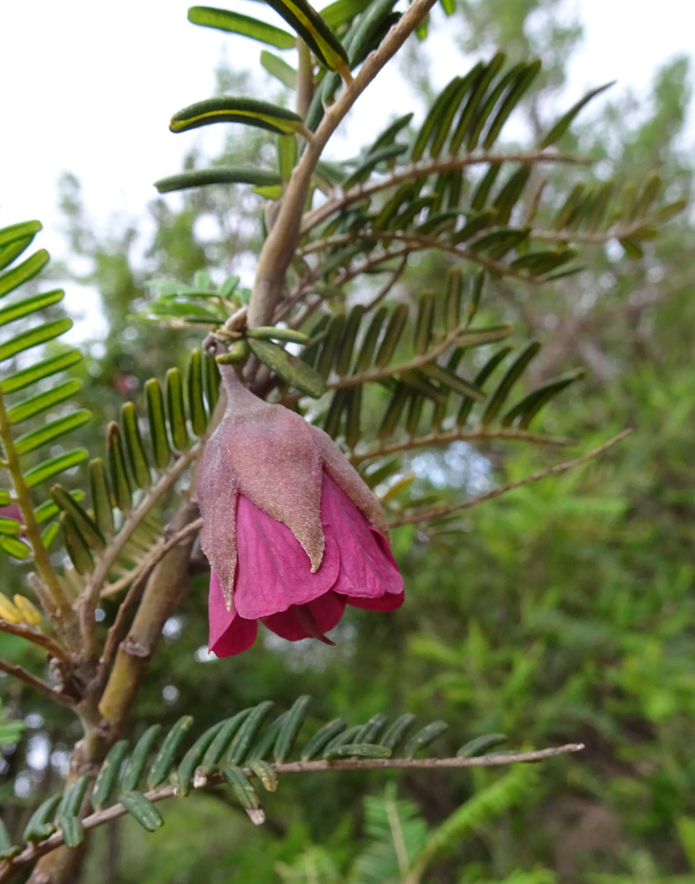
Fig. 2. Cropped. File size 2.714MB
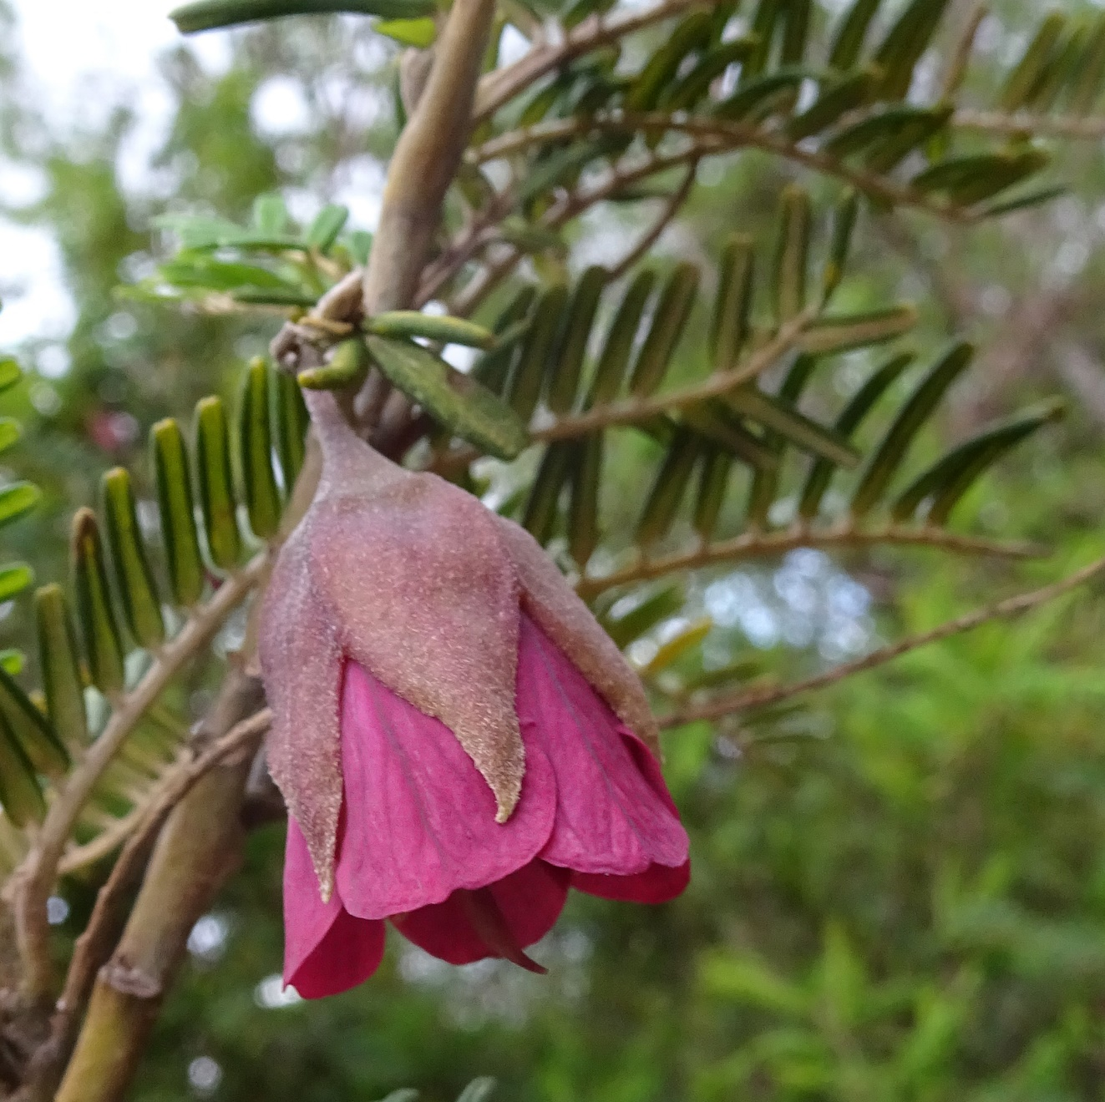
Fig. 3 Cropped and quality 8. File size 581KB
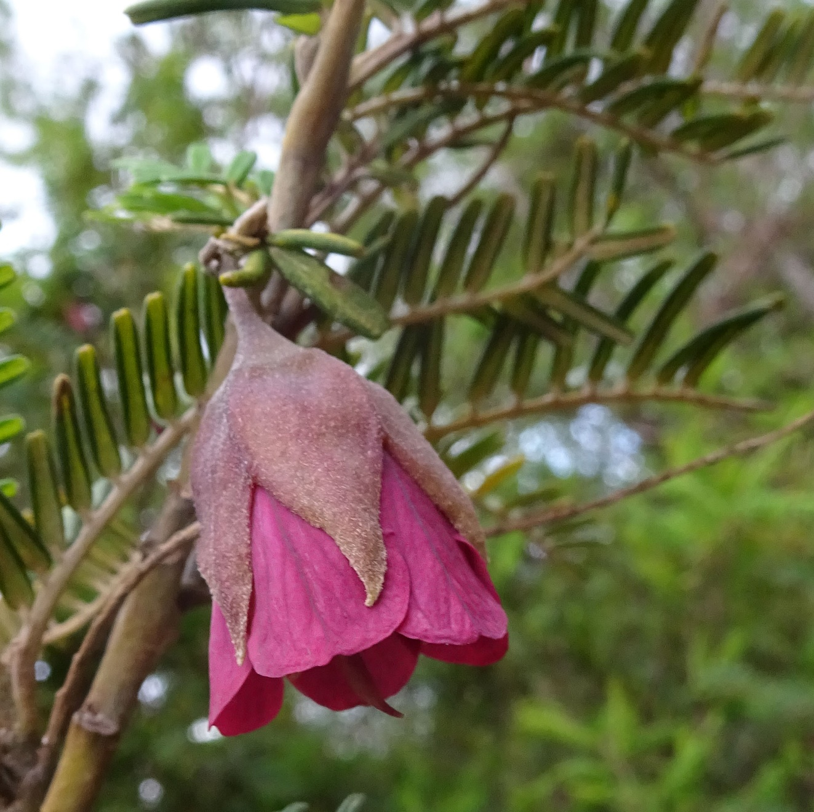
Fig. 8 Cropped, quality 8, maximum dimension 1000 pixels. File size 218KB
