Preparing Herbarium Specimen Labels
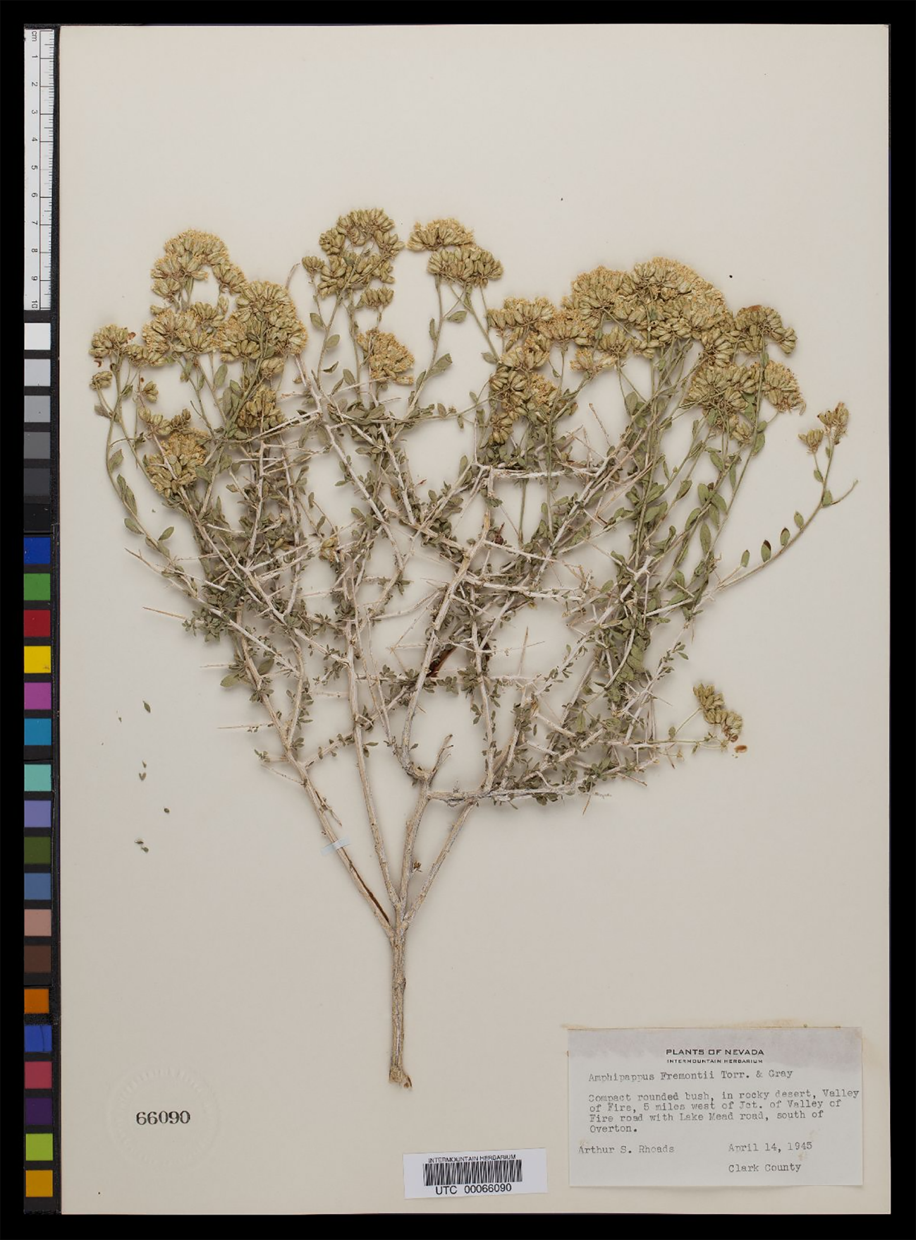
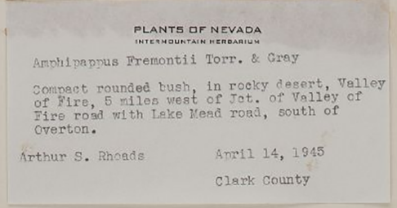
A herbarium specimen consists of carefully prepared plant material and a label that states the name of plant and when, where, and by whom the plant material was collected. The label information is just as important as the plant material. When plant collecting started, very little information was put on the labels, perhaps just “Africa” for a collection from Somaliland. With time, botanists realized that putting more information on their specimens increased their value both for themselves and for their colleagues. When people working in natural history collections, including herbaria realized that people wanted to be able to use computer technology to look at data from specimens in many different collections, they decided to come up with a standard way for recording the most important kinds of information.
Symbiota, the software that runs OpenHerbarium.org, is designed to store information in this standard manner but it also permits collecting additional information about aspects that are important to plants, such as the kind of substrate the plant is growing on. We shall go through the form used for data entry in Symbiota, discussing how to fill out the fields that are important when you are collecting. It requires entering data online in your personal account. Eventually, my colleague and I plan to develop a program that will allow you to enter your information in an offline database and then upload it when you are ready but that program does not exist as yet.
As a first step, please create an account for yourself in OpenHerbarium.org and send me an email when you have done so. Then I shall give you permission to use the software online for your own specimens. To create an account, go to http://openherbarium.org and click on “new account” in the left hand frame. This will bring up a page asking you for information about yourself. Note that the only information reuired is that is in the top box; providing the information indicated in the lower box is optional.
Data Entry Form - General
The data entry form for labels is the same as that used to record an observation or to enter data from an existing specimen into a herbarium database. Some of the boxes are ignored when the form is being used to enter the information needed to create a label. They are marked as such.
Data Entry Form – Box 1
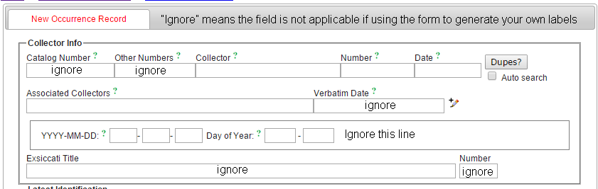
The first box collects the “who” and “when” of a specimen.
Collector: Your name. Please be consistent in how you write it. Your specimens will become part of your professional record. If you have an ORCID (see http://orcid.org), you could enter it after your name but be consistent in doing so. An ORCID is a unique identifier for you as a researcher.
Number: You should give each specimen you collect a separate number. Your field notebook can be used to keep track of them. Some people keep consecutive numbers from their first collection. I use the year followed by a number, e.g., 2015.001.
Date: The standard format is year-month-day. For example 2015-05-05. There are other formats you can
Associated Collectors: Here you list the people you are collecting with. For this training collecting trip, enter “Other members of Hargeisa 2015 Training Session”.
Date Entry Form – Box 2
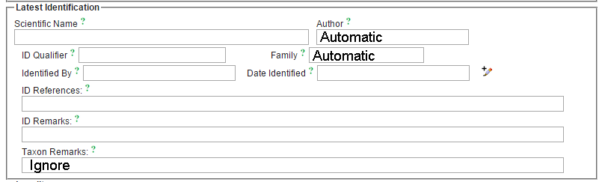
This box is about the plant’s scientific name. If you have not been able to identify the plant, leave it blank. A good specimen can often be identified by an expert from a herbarium specimen. What no one else can do is provide the information on when, where, and by whom it was collected.
Scientific name: If you have identified the plant, enter the scientific name here. The program will let you know if you have entered a name that is in its names table by suggesting a name based on what you have typed in. If it does not make a suggestion, check your spelling carefully. If the name is in the database, the author and family fields will be completed automatically.
If it is still a problem, EMAIL me (mary.barkworth@usu.edu) telling me the name you could not find. It is possible that I have not added it to the database. I have added all names in the Flora of Somalia but other references, particularly older references, may use a different name from that used in the Flora. You will be able to enter the scientific name but you will also need to enter the family. This can be discovered by looking up the genus at http://tropicos.org.
ID Qualifier: Sometimes people feel a plant is close to a species they know but not the same. This field is used for comments like “close to”.
Identified by: The name of the person who identified the plant. This might be you but it also might be someone else, for example your team leader. Whoever it is, that is the name that goes here.
Date identified: It is best to put in the actual date in the format 2015-05-05 but you can put in just the year as 2015-00-00 or just the month as 2015-05-00. “00” is used to indicate unknown.
ID references: Enter the name of the reference you used for identification, e.g., Trees and Shrubs of Somalia, Flora of Somalia.
ID remarks: This is usually left blank but you might comment on the features that you relied on. “Relied on leaf shape for identification because plant not in flower”. But, as I said, it is usually left blank.
Data Entry Box 3
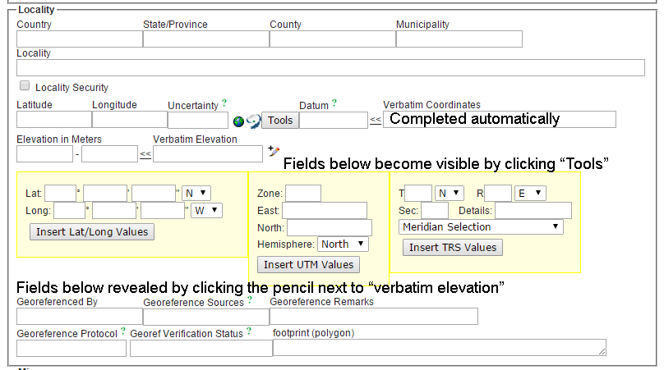
Country: I shall add “Somaliland” to the choices when I return to the US. I think all recognized countires have been added but I need to check that.
StateProvince: I shall add Awdal, WooWoqoyi Galbeed, Togdheer, Sanaag, and Sool to the list of possibilities when I return. I shall also add in data for Somalia.
Locality: Describe the locality in words. For example “5.2 km south of Hargeisa on highway that goes through Hargeisa Airport”, “Grounds of Maan Soor Hotel, Hargeisa, about 30 m north of main building”.
Latitude and Longitude: These need to be in decimal degrees. Locations in Somaliland will be positive for both values. If you click the “Tools” button, the fiels in the block immediately below will be revealed. The set on the left will enable you to enter the latitude and longitude in degrees, minutes, and seconds but you must click “Insert lat/long values” to have the latitude and longitude fields completed. When you do so , the information you entered will be placed in the “Verbatim coordinates” field and the decimalized version entered into the latitude and longitude fields.
If you do not have a GPS unit when you collect, use Google Earth or Google Maps to obtain your location later. Google Earth, the free version will enable to locate your collecting point very accurately. You can also use a map to determine the lat/long coordinates of a location. We shall not go over how to do so because I am not familiar with maps for Somaliland.
Uncertainty in meters: There are two aspects to uncertainty. First, are the lat/lon data you entered for the plant collected or did you record them once for an area and then collect over the area? If you collected over an area, the uncertainty is an estimate, in meters of the radius of a circle that would include the whole area you collected in. If the lat/lon data are for a single plant, then us 25m. The reason for this is that small, inexpensive GPS units, even under the best conditions (lots of satellites, no mountains, no large buildings) are no more accurate than 25 m. If you use Google Earth, the uncertainty may be greater. Incidentally, giving someone directions that will take them within 25 m of your collecting site, is pretty good.
Datum: This is the model of the earth used in determining the latitude and longitude. GPS units, by default us what is called the WGS84 datum as does Google Earth and Google Maps. If you use a printed map, the datum should be written on it somewhere.
The best way I can think of to explain datum is to ask you to imagine that you have rulers that all use centimeters but some are straight and some are curved. If you used different rulers to measure a distance, you would get different answers; you would need to tell someone which ruler you used for them to get the same measurement. Datums are like different rulers. Some datums are designed to be particularly good models of one portion of the world. WGS84 is the most recent one that is well suited for use around the world and zooming in and out of a map. It was developed using satellite data.
Elevation in meters: DO NOT MEASURE THIS WITH A GPS UNIT (unless you have a very expensive one). Probably the easiest way to go is to use the elevation finder at http://www.freemaptools.com/elevation-finder.htm. This will give you the information in meters or feet. Use meters. If your data are in feet (perhaps a map), then enter the data in the other box as “1200 ft” or “800-1200 ft”. It will automatically be converted to meters and placed in the appropriate box.
Of the remaining boxes, you only need to complete two:
Georeferenced by: Enter your name
Georeferenced sources: This might be GPS unit, Google Earth plus Google Maps, or Geolocate. If you use a printed map, name it.
Data Entry Box 4
This box, which is shown on the next page, is where you put ecological information and information descriptive information about your specimen.
Habitat: There are no rules for describing habitats. You have to use your judgement as to what is significant for your plant. Here are some examples. “Along road leaving hotel grounds”. “Waste area around the hotel”. “Sandy desert with scattered heavily grazed trees and shrubs and little ground cover”. “Adjacent to water course. In area shaded by some tall trees and surrounded by shrubs”. “On steep west-facing slope. Growing in soil pockets among rocks”.
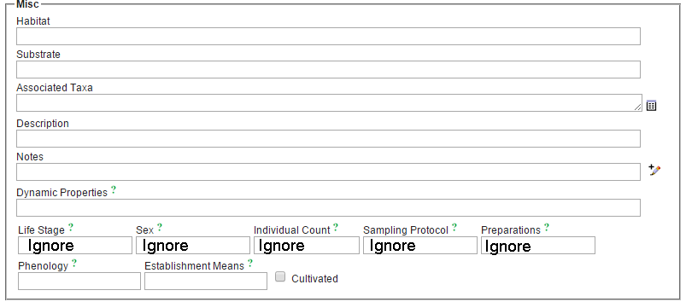
Substrate: This field is often left blank by people collecting vascular plants but you can use it to say things like “Sandy soil derived from red sandstone” or “Shallow, sandy soil”.
Associated taxa: Scientific names of species that were growing in the same area. If you only know a vernacular name, list the associated species in the habitat field. Clicking the table on the right will help make sure that you spell the scientific names correctly.
Description: This is descriptive information about the plant you collected or sampled. It should include the information that will not be evident from your specimen. Woody plants: state whether it was a tree or a shrub and its approximate height. Herbaceous plants: state whether it was annual or perennial and, for perennial plants, whether it has a rhizome, a tap root, bulb, corm, or woody caudex.
Notes: Any additional information that might be of interest. Some examples: “Used locally to encourage sleep”, “With many ants crawling up its stem”.
Dynamic properties: If you make measurements on your plant or the conditions where it was growing, this is where you can store the information. Some examples: awnLengthInMeters=0.014, heightInMeters=1.5, relativeHumidity=28, airTemperatureInC=22
Phenology: This means much the same as life stage. I suggest using one of the following (or a combination): Vegetative, In bud, flowering, fruiting, fruit/seeds dispersed.
Establishment: For wild plants, leave blank. “Planted” or “Seeded” would mean that humans started the plant and then left it to grow (or not). “Cultivated” means that the plant is being actively tended to by humans – watered, trimmed, the area around weeded. If it is cultivated, also check the cultivated box. This makes it easier for data users to delete the cultivated records (or select only cultivated records).
Data Entry box 5
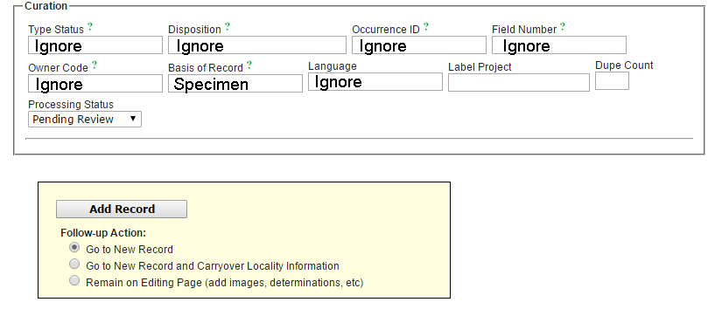
Basis of record: You will need to change this for specimen. The alternatives are “Image” or “observation”.
Label project: This is used to identify sets of labels that you wish to print. You could put the date in or call it “Training2”.
Dupe Count: How many specimens did you collect from the same plant or, in the case of herbaceous plants, from the same area? This information will be used to print off the correct number of labels.
Add record: This is the point at which you save your label information but first you must choose one of the three options listed below. The default is to move to a new record but, if you collected multiple specimens from one location, choose option 2 before clicking “Add record; it will save you a lot of work. If you have images you want to add, you can add them now by selecting option 3 before clicking “Add label”. If you have more specimens from the same locality AND images, choose the second option, carryover locality information. It is just as easy to add images later; it is a pain having to reenter locality information.

