Symbiota: image-vouchered records
Text by Mary E. Barkworth; original image of Cadia purpurea from Helen Pickering. Prepared 2017-05-29.
-------------------------------
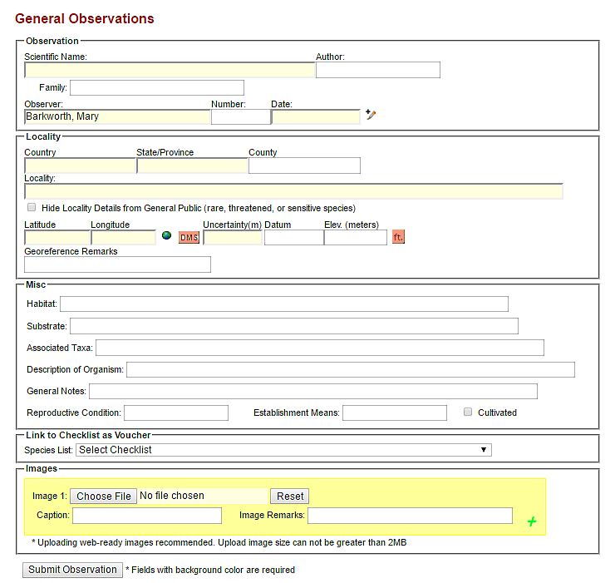
Image-vouchered records are those for which an image is available AND there are good location data associated with it. At a minimum, it must be possible to provide the latitude and longitude where you photographed the plant but the form encourages addition of additional information. To find the form for submitting image-vouchered occurrence records, login to OpenHerbarium (or the Symbiota network you are using), then go to “My profile”, “Specimen Management”, “Submit image vouchered observation”. If you do not see the “Submit image-vouchered observation” option when you click on the specimen management tab, send an email to the network manager (mary.barkworth@gmail.com for OpenHerbarium and OpenZooMuseum), asking to be given permission to do so. The network manager will want to verify that you can reliably identify the organisms involved so please suggest who can support your request. The reason for this requirement is to ensure that the networks become known as reliable sources of information.
Fig. 1. Data entry form for image-vouchered observations. Yellow fields are required; pink boxes link to alternative ways of entering latitude and longitude information (DMS) or elevation (ft).

Basic Field Image Submission
To provide images to illustrate what a taxon looks like even though you do not have location data for the plant, use the “Basic Field Image Submission” tool. If you have permission to do so, the link will appear when you login and then click “Site map”. Permission will be given to individuals who have the recommendation of a local curator for their knowledge of the organisms involved and ability to provide good, well-focused images.

Instructions

Prepare the images.
Images should be of high quality. This means they must be in focus and feature something about the plant (flower, growth form, habitat) that will aid those seeking to identify the species. They must also be smaller than 2MB. Smaller is better because small files download faster than large files.
The file size of an image is the digital size of the image file, measured in kilobytes (K), megabytes (MB), or gigabytes (GB). It is proportional to the pixel dimensions of the image. Images with more pixels may produce more detail at a given print size but they require more disk space to store and are slower to download. File format also affects file size. Because of the varying compression methods used by GIF, JPEG, PNG, and TIFF file formats, file sizes can vary considerably for the same pixel dimensions. Similarly, color bit-depth and the number of layers and channels in an image affect file size.
Note that the File size reported in Photoshop under “File size” is NOT the size in megabytes. To see that, one must open the folder and look under the appropriate file name. Keep an eye on it as you modify the images.
Always save your modified files under a different name from the original file.
The following steps are those I take in preparing images for upload. I use Photoshop. Other programs have similar abilities.
- Open the file.
- Crop the file so that the feature of interest is highlighted. It is also good to make them somewhat square – they look better when many images are viewed at once.
- Reduce the resolution to 144 pixels/inch. This will not affect how the it shows up on a screen. It will affect how it prints. One needs high resolution for printing (at least 300 pixels/inch) but not for screen display. With screen display, it is the ability of the monitor/cell phone to display higher resolutions that determines how an image looks. A resolution of 144 will look good on most monitors but, when printed, will look a bit fuzzy (see Fig. 4).
- Reduce width to 1000 pixels. This will be too big for some monitors but not all. It is an easy number to remember.
- Save as JPG file. For the Cadia purpurea image used to illustrate the impact of each of the above steps, this reduce the file size to 767 KB, a very acceptable level.
- In Photoshop, one can reduce the file size further by using the Export/Save for Web option. This reduced the file size to 752 KB, a saving not worth bothering with.
Figures 2-7 illustrate the difference each step makes to the file but, inevitably, does so in print format.

Submit the observation
Once the image(s) for an observation have been prepared, it is time to create the image-vouchered recorded. It is possible, even desirable, to have more than one image per image-based record if they show different aspects of the plant.
- Log in to your account and then go to “My profile” (in left frame), “Specimen Management” (central tab), and then “Submit image-vouchered observation”.
- Complete the form. More information is better than less but only the yellowed fields (Fig.1) are essential. If you do not have the required information but are confident of the determination, the images can be submitted as “field images” for which there are separate (but similar) instructions.
- Scientific name: Ideally identified to species or below but it is possible to indicate just the genus or the family. If you enter a name at generic level or below, the author and family should completed automatically. If they are not, send the network manager a message stating which name you wish to add. It needs to be added to the backbone. If you can only identify the plant to family, you will need to complete the family field.
- Country, stateprovince, county. Country is straightforward. The system does accept Somaliland. StateProvince is the next political level down, Region in the case of Somalland. County is the political level down from that, District in the case of Somaliland.
- Locality: a verbal description of the location, for example, 23 km from a village on the track to ….
- Latitude and longitude. These need to be in decimal format. If you have them in degrees, minutes, and seconds, click the DMS button and it will bring up fields for entering them. After doing so, be sure to click the “Insert latitude/longitude values” button.
- Elevation in meters. If you have the elevation in feet, click the pink “ft” button for a field that enables you to enable the number and, when you click the “insert elevation” button, will put the appropriate number into the elevation in meters field.
- For observations in an area for which a checklist is being developed, use the drop down menu on the “Link to checklist as voucher” field to add your record automatically to the checklist.
- Select the (first) image file you wish to associate with the record. To add additional images for this observation, click on the green plus sign.
And that is it. If you have questions, please send them to me mary.barkworth@gmail.com.
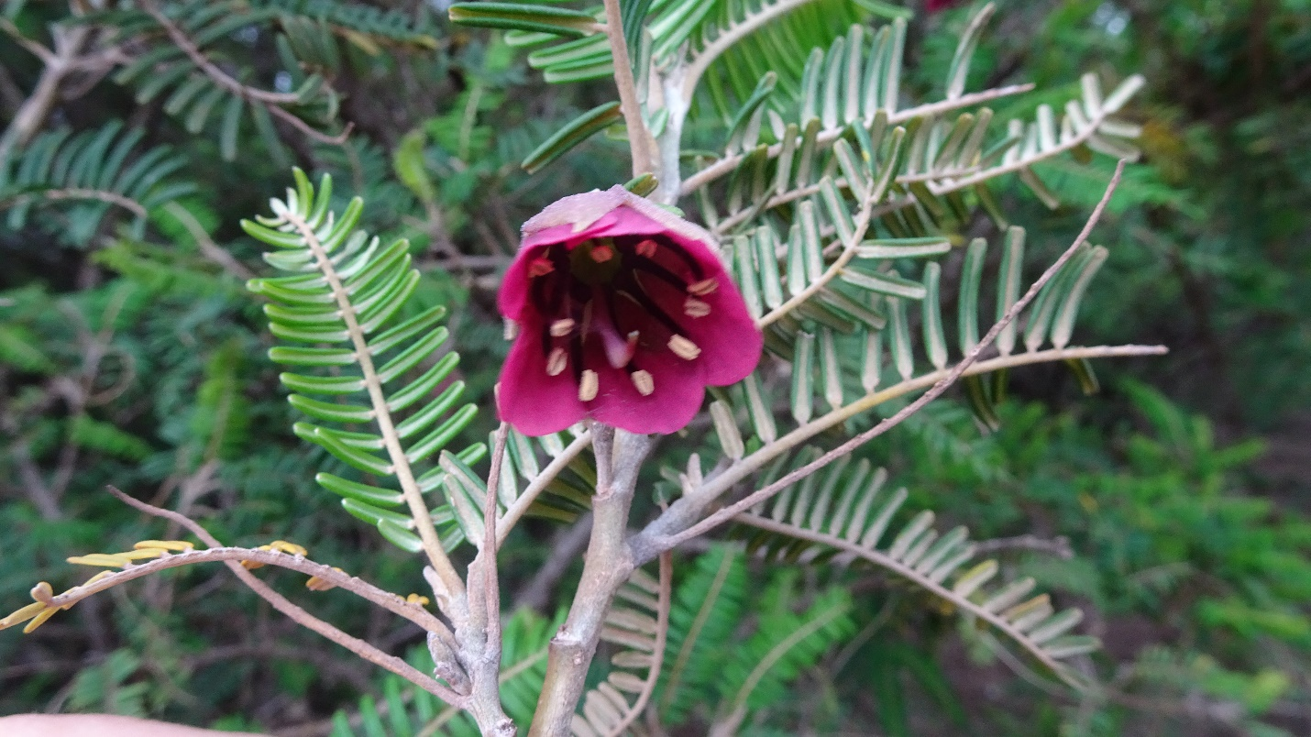
Fig. 2. Original JPG image. File size 3.82 MB
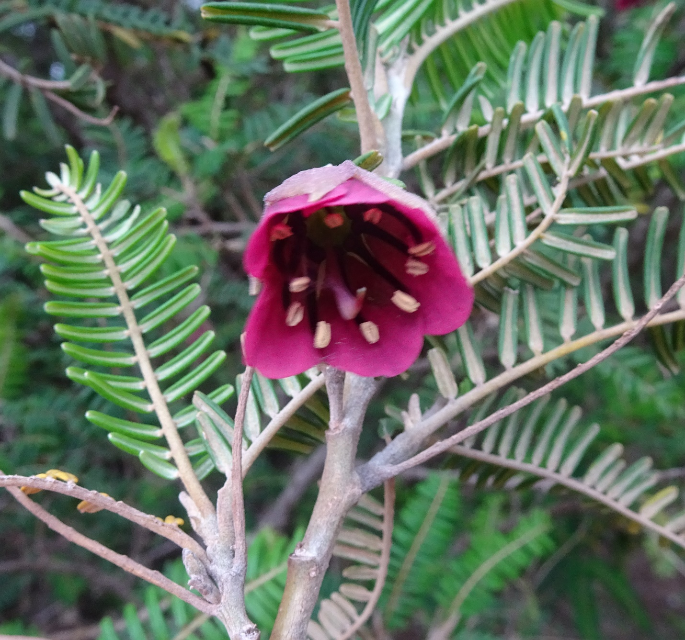
Fig. 3. Cropped JPG image. File size 4.134MB. resolution 350 pixels/inch.
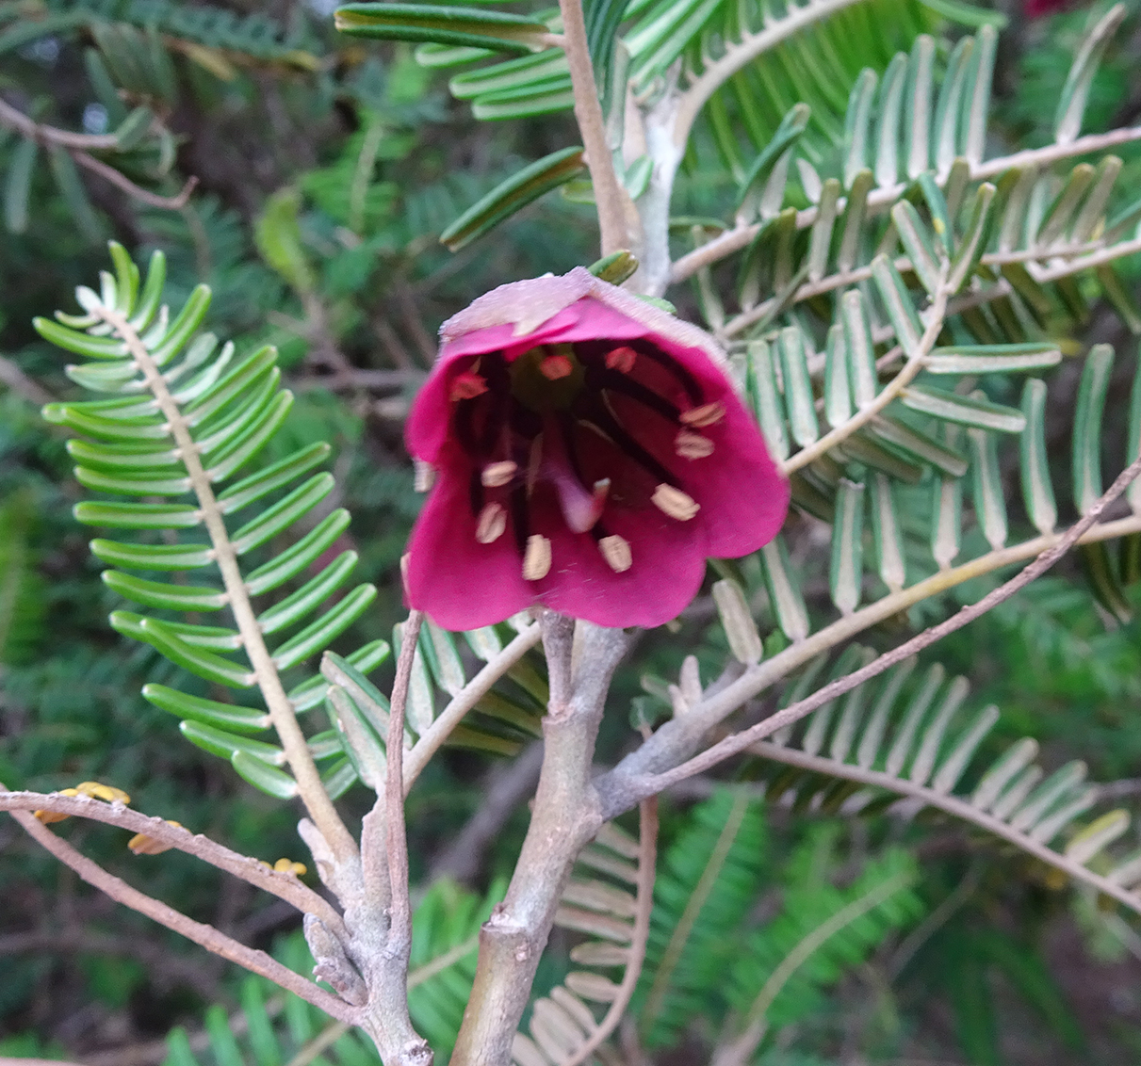
Fig. 4. Cropped JPG image with resolution 144 pixels/inch. File size 1.065MB
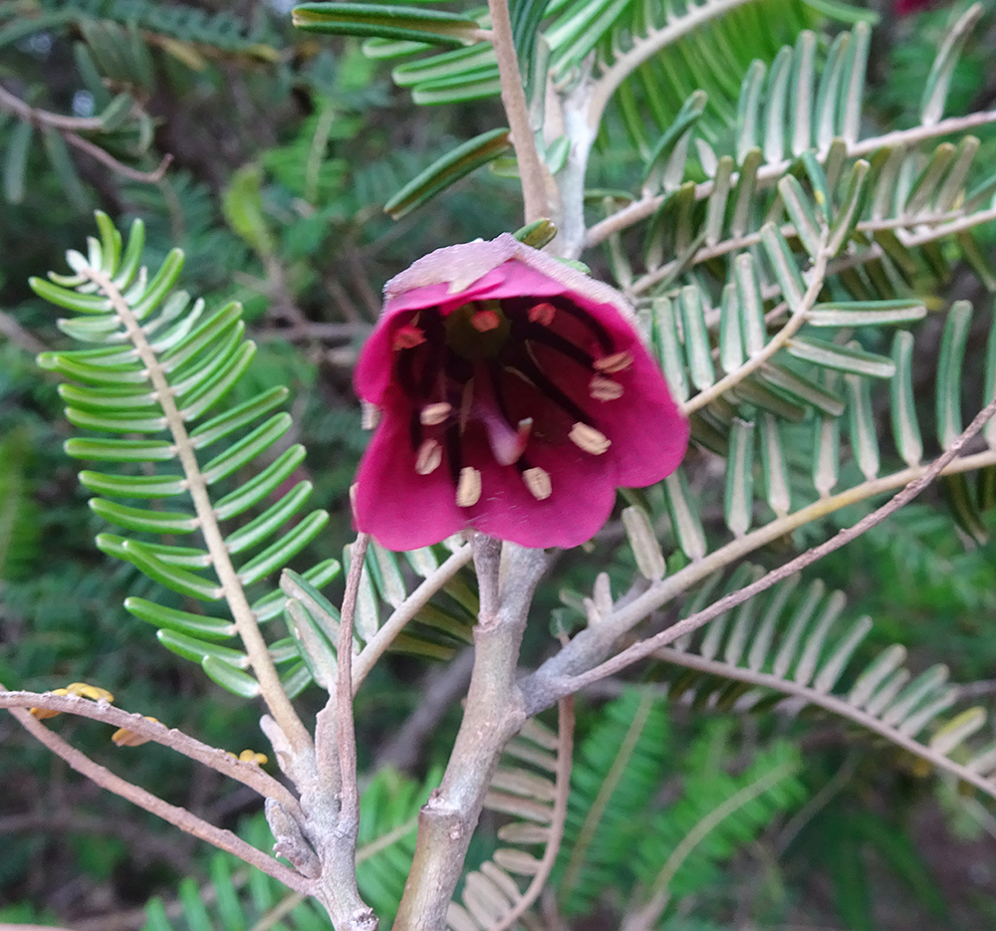
Fig. 5. Cropped JPG image with resolution 144 pixels/inch, width 1000 pixels. File size 767KB
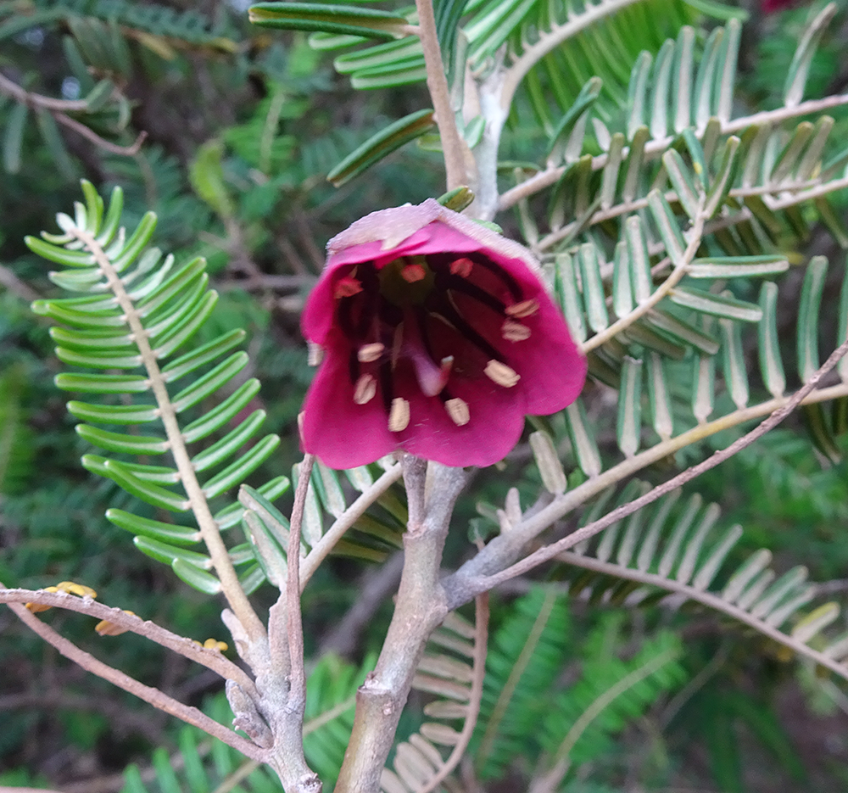
Fig. 6. Cropped PNG image with resolution 144 pixels/inch, width 1000 pixels. File size 2.4 MB
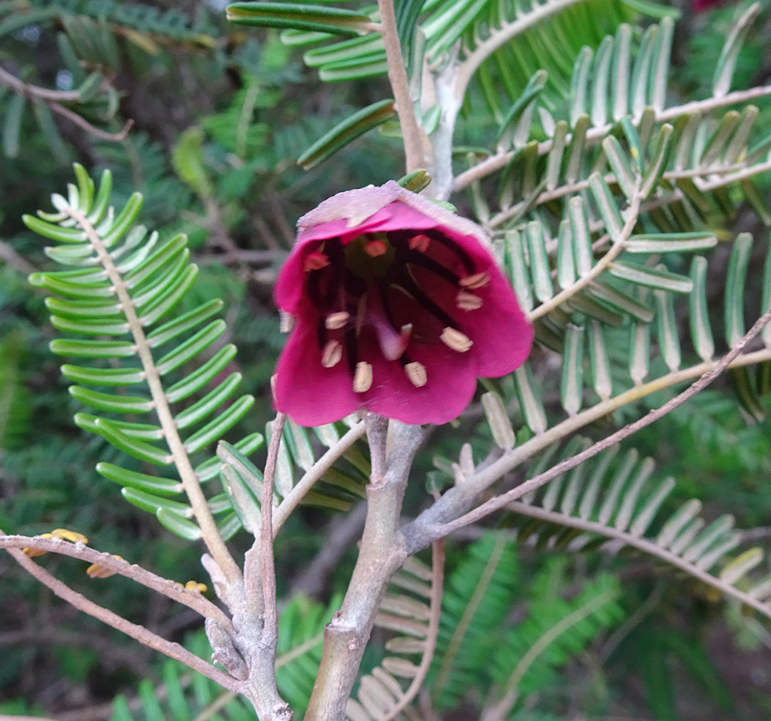
Fig. 7. Cropped JPG image, resolution 144 pixels/inch, width 1000 pixels, saved for Web. File size 757 KB.

Modified slightly from Photoshop online help, accessed 2017-05-29

